Chapter 10 Analysis of organic compounds
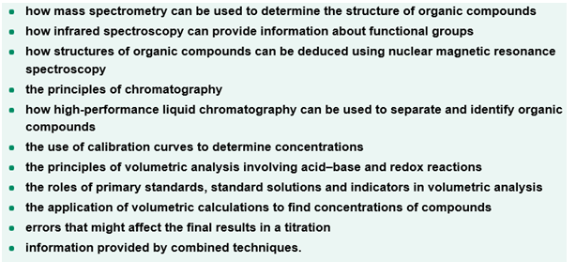
Test 10
Section A (20 marks)
1. Which of the following would be an example of quantitative analysis?
A. the identification of metal ions using a flame test
B. using chromatography to identify the number of different compounds present in pen ink
C. determining the concentration of ethanoic acid in a vinegar solution
D. identifying the amino acids present in orange juice

2. The chlorine atom has two isotopes, ³⁵Cl and ³⁷Cl. When chlorine gas, Cl₂, was analysed in a mass spectrometer a range of positively charged particles were formed. Which of the following positively charged particles would be deflected least by the magnetic field?
A. [³⁵Cl]⁺
B. [³⁷Cl]⁺
C. [³⁵Cl³⁷Cl]⁺
D. [³⁷Cl³⁷Cl]⁺

3. Ethanoic acid and methyl methanoate both have the same molecular formula (C₂H₄O₂).
If IR spectroscopy was used to distinguish between these compounds, which of the following wavenumber ranges would be most useful?
A. 1000 – 1300 cm⁻¹
B. 1670 – 1750 cm⁻¹
C. 2500 – 3500 cm⁻¹
D. 2850 – 3300 cm⁻¹

4. The number of different ¹H and ¹³C NMR environments in 2-methylbutan-2-ol would be respectively
A. 4 and 4
B. 4 and 5
C. 5 and 4
D. 5 and 5

5. The ethyl group (CH₃CH₂-) is easily identified using NMR spectroscopy because its' splitting
pattern Is
A. a triplet and a doublet
B. a triplet and a quartet
C. a singlet and a doublet
D. two triplets

6. The separation of the components of a mixture using paper chromatography is due to the
processes of
A. absorption and desorption
B. adsorption and desorption
C. adsorption and absorption
D. stationary phases and mobile phases

7. When a mixture is separated using HPLC, the component that comes off the column last
A. adsorbs most to the stationary phase and has the smallest retention time
B. adsorbs most to the stationary phase and has the largest retention time
C. adsorbs least to the stationary phase and has the smallest retention time
D. adsorbs least to the stationary phase and has the largest retention time

Questions 8 and 9 involve the use of the following information:
The following pH curve was obtained for a titration between an acid and a base

pH
volume of base (mL)

8. The pH curve indicates that the reaction was between a
A. strong acid and a strong base
B. strong acid and a weak base
C. strong base and weak acid
D. weak base and weak acid

9. Which of the following indicators would be the best choice to use for the titration?
A. phenolphthalein
B. thymol blue
C. phenol red
D. methyl red

10. The point is a reaction where the reactants are in the exact mole ratio as shown by the balanced
equation is called the
A. the equivalence point
B. the neutralisation point
C. the end point
D. the indicative point

Section B (30 marks)
1. Compound X was found to contain 48.63% carbon, 8.18% hydrogen and 43.19% oxygen.
The mass spectrum of X showed a molecular ion peak at m/z = 74 along with fragments at m/z = 59,
45, 29 and 15.
The information in the following table was obtained from its ¹H NMR:
Peak | Number of H atoms | Chemical shift (δ) | Splitting
1 | 3 | 1.2 – 1.4 | triplet
2 | 2 | 4.1 – 4.3 | quartet
3 | 1 | 8.1 | singlet
The IR spectrum is given below.

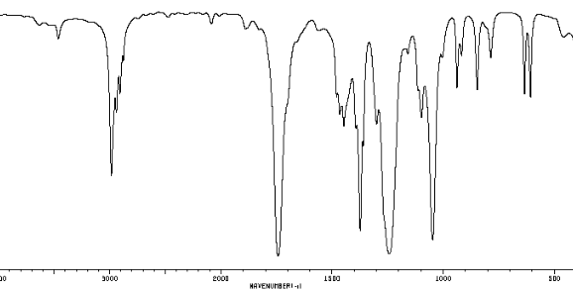
(a) Determine the empirical formula of X
(b) Use information from the mass spectrum to determine the molecular formula of X
(c) Explain why the molecular formula suggests that X is either a carboxylic acid or an ester. Draw
structures of three carboxylic acid and/or ester molecules that have this molecular formula.
(d) Use the information from the IR spectrum to complete the following table
Wavenumber(cm⁻¹) | Caused by the presence of which bond?
≈ 3000
≈1750
≈ 1230
What does the absence of a peak at 2500 - 3300cm⁻¹ tell you?
(e) Compare the number of H atoms in the molecule to the actual number of protons in each
¹H NMR environment. What information does this comparison provide?
Use the information from the ¹H NMR spectrum to complete the following table
Chemical shift | Number of H atoms | Hydrocarbon group | Type of proton (using the Data Booklet)
1.2 – 1.4 | 3 | CH₃
4.1 – 4.3 | 2 | CH₂
8.1 | 1* | CH
* while a peak area of one H could be due to a O – H group, a glance at the IR spectrum shows
that there is no O – H bond in X

(f) What does the quartet / triplet splitting tell you about the hydrocarbon groups in X?
(g) Draw the structure of X. What is the chemical name of X?
(h) Show that the fragments at m/z = 59, 45, 29 and 15 are consistent with this structure.
[2 + 1 +1 + 3 + 3 + 1 + 1 + 1 = 13 marks]

2. The painkiller phenacetin was the world's first synthetic pharmaceutical drug. It was developed by an American chemist and began distribution in 1887. Phenacetin was often accompanied by aspirin and caffeine in what were called APC pills. These pills were widely distributed during and after World War II. The use of phenacetin in the U.S. was discontinued in the 1980s because of links to cancer and other adverse side effects, but it remains available in some countries.
An APC pill was dissolved in a suitable solvent and analysed using HPLC. The results are shown in
the chromatogram below
< remove this stuff >
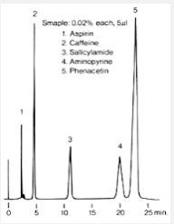
(a) Which of the peaks (1 – 5) in the chromatogram of the APC adsorbed
(i) most to the stationary phase?
(ii) least to the stationary phase?
(b) Describe an experiment that would enable you to determine which of the peaks in the
chromatogram of APC was due to the presence of phenacetin.
(c) To determine the amount of phenacetin in an APC tablet using HPLC, a set of 5 reference standards of known phenacetin concentration were run through the instrument for the purpose of calibration. A 0.0336 g sample of an APC tablet was then dissolved in a suitable solvent and made up to 100.0mL in a volumetric flask. This APC sample solution was then analysed under exactly the same conditions as the reference samples.
The results obtained are shown in the table below:
Concentration of phenacetin (mg L⁻¹) | Peak area
0.00 | 0
1.00 | 154
2.00 | 298
3.00 | 448
4.00 | 606
5.00 | 750
Sample | 375
Using these results plot a calibration curve of concentration (X axis) against peak area
(d) Use the graph to deduce the concentration of the phenacetin solution in mg L⁻¹.
(e) Determine the % m/m of phenacetin in the tablet.
[2 + 2 + 2 + 1 + 2 = 9 marks]

3. As a part of an experimental investigation a student decided to determine the amount of
Aspirin (2-acetoxybenzoic acid) in a headache tablet. The structure of aspirin is given below
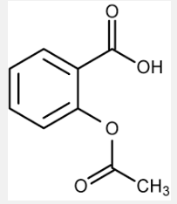

The manufacturer claimed that the tablets contained between 30 – 35 % (m/m) of aspirin.

In the investigation the student dissolved an aspirin tablet weighing 251.2 mg in approximately 50
mL of water in a 250 mL conical flask. In the titration the aspirin required 35.19mL of a 0.01278 M
sodium hydroxide solution. Note that aspirin is a mono-protic acid.

(a) Given that the aspirin acts as a weak acid, what indicator would have been suitable for this
volumetric analysis exercise?
(b) Write a balanced chemical equation for this reaction and then use the equation to determine the
percentage by mass of aspirin in the tablet.
(c) Comment on the manufacturer’s claim.
(d) What equipment would have been used to measure the
(i) volume of NaOH?
(ii) volume of water?
(e) What would have been the effect on the answer if 100 mL of water was used rather than 50 mL?
Explain your answer.
[1 + 3 + 1 + 2 + 1 = 8 marks]

Solutions for test 10
Section A (20 marks)
1. A
2. D
3. C
4. A
5. B
6. B
7. B
8. C
9, A
10. A

Section B (30 marks) [marks are denoted by square brackets]
1(a) C : H : O
48.65 8.11 43.24
48.65/12.0 8.11/1.0 43.24/16.0 [1]
4.05 8.11 2.70
4.05/2.70 8.18/2.70 2.70/2.70
1.50 3.00 1
X2 3 6 2
the empirical formula of X is C₃H₆O₂ [1]
(b) The molecular ion peak at m/z = 74 shows that the molecular mass of X is 74
The ratio mass of molecule / mass of empirical formula = 74 / 74 = 1
Therefore the molecular formula is C₃H₆O₂ [1]
(c) The C₃H₆ part (the C_{n}H_{2n} part) of the molecular formula tells you that there must be a double C=O bond. (While a double C=C bond may also be possible a glance at the IR spectrum indicates the presence of a C=O bond.)
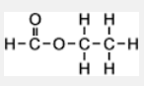
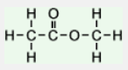
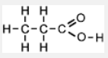
< it would be great if these 3 structures could be beside each other ? > [1]

(d)
Wavenumber (cm⁻¹) | Caused by the presence of which bond?
≈ 3000 | C - H
1750 | C = O
1230 | C - O
The absence of a peak at 2500-3300cm⁻¹ precludes the presence of an O – H (acid). That is, X must be an ester. [3]
(e) There are six H atoms in the molecule which is the same as the total number of H atoms in the three hydrocarbon groups listed in the table. That is X must contain a CH₃, a CH₂ and a CH group.

Chemical shift | Number of H atoms | Hydrocarbon group* | Type of proton using the Data Booklet
0.9 – 1.1 | 3 | CH₃ | R - CH₃
4.1 – 4.3 | 2 | CH₂ | O  R C  OCH₂R
8.1 | 1* | CH | O  R C  H
[6 x ½ ]
(f) There must be an ethyl group (CH₃CH₂ - in X. [1]
(g) ethyl methanoate

[1]
(h) m/z 59 [HCOOCH₂]⁺
m/z 45 [HCOO]⁺
m/z 29 [CH₃CH₂]⁺ or [HCO]⁺ [1] for a minimum of 3 correct responses
m/z 15 [CH₃]⁺

2(a)(i) peak 5
(ii) peak 1 [2]
(b) With the knowledge that APC pills contain phenacetin, aspirin and caffeine, HPLC could be used for pure samples of each of these three compounds and their retention times matched to the retention times obtained for the APC sample. [2]
(c) [1] for the labelling of the axes [1] for the plotting of the points
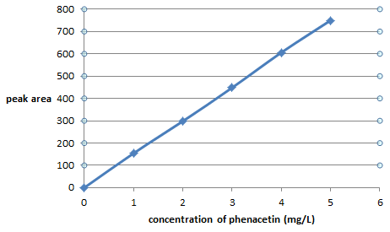
[2]
(d) The concentration of the phenacetin = 2.50 mg L⁻¹ [1]
(e) If there is 2.50 mg of phenacetin in 1 L (1000 mL) of solution
There will be 0.250 mg of phenacetin in 100mL of solution [1]
That is there will be 0.250 mg (2.50 x 10⁻⁴ g) of phenacetin in 0.0336 g of an APC tablet
% phenacetin = (2.50 x 10⁻⁴ g / 0.0336 g) x 100 = 0.744 % (m/m) [1]

3(a) phenolphthalein [1]
(b) C₉H₈O₄ + NaOH C₉H₇O₄Na + H₂O
M(tablet = 251.2 mg = 0.2512 g
n(NaOH) = c x V = 0.01278 x 0.03519 = 4.497 x 10⁻⁴ mole [1]
n(aspirin) = n(NaOH) = 4.497 x 10⁻⁴ mole [1]
m(aspirin) = n x M = 4.497 x 10⁻⁴ x 180.0 = 8.095 x 10⁻² g
% aspirin = (8.095 x 10⁻²) / 0.2512 x 100 = 32.26 % [1]
(c) The result of 32.26% falls within the manufacturers claim [1]
(d)(i) a burette [1]
(ii) a measuring cylinder [1]
(e) There would be no effect because the amount in mole of aspirin in the flask would not have changed. [1]

